UCS 2312 Data Structures Lab

Date of Assignment: 11.12.2023

Exercise 12: Implementation of Hash Table using Closed and Open addressing methods
[CO2, K3]

The HashTableADT contains hash table and its size. Hash function to be used for the insertion of elements is x mod tableSize. Use Separate chaining method to resolve the collision.

- void init(HashTableADT *H) – To initialize the size of Hash Table
- void insertElementL (HashTableADT *H, int x)– To insert the input key into the hash table
- int searchElement(HashTableADT *H, int key) – Searching an element in the hash table, if found return 1, otherwise return -1
- void displayHT(HashTableADT *H) – Display the elements in the hash table

Note:

- Implement HashTableADT with the specified operations in HashTableADTImpl.h
- Write a menu driven application to utilize the HashTableADT.

1. Demonstrate ADT with the following test case
insert 23, 45, 69, 87, 48, 67, 54, 66, 53

Contents of Hash Table
(Separate Chaining)
0 :
1 :
2 :
3 : 23 53
4 : 54
5 : 45
6 : 66
7 : 87 67
8 : 48
9 : 69

CODE:
Hashing.h
#include <stdio.h>
#include <stdlib.h>

struct node
{
int data;
struct node *next;
};

struct hash
{
int size;
struct node *list[100];
};

void create(struct hash *h, int size)
{
h->size = size;
for (int i = 0; i < h->size; i++)
{
h->list[i] = (struct node *)malloc(sizeof(struct node));
h->list[i]->next = NULL;
}
}

void insert(struct hash *h, int x)
{
int index = x % h->size;
struct node *temp;
temp = (struct node *)malloc(sizeof(struct node));
temp->next = NULL;
temp->data = x;

struct node *ptr;
ptr = h->list[index];
while (ptr->next != NULL)
ptr = ptr->next;
ptr->next = temp;
}

int searchElement(struct hash *h, int key)
{
int index = key % h->size;
struct node *ptr = h->list[index]->next;
while (ptr != NULL)
{
if (ptr->data == key)
return 1;
ptr = ptr->next;
}
return -1;
}

void displayHT(struct hash *h)
{
struct node *ptr;
for (int i = 0; i < h->size; i++)
{
printf("%d -> ",i);
ptr = h->list[i]->next;
while (ptr != NULL)
{
printf("%d ", ptr->data);
ptr = ptr->next;
}
printf("\n");
}
}

Q1.c
#include <stdio.h>
#include <stdlib.h>
#include "hashing.h"

int main()
{
struct hash *h;
h = (struct hash *)malloc(sizeof(struct hash));
int size, ch, element, key, x=1;

printf("Enter the size of the hash table: ");
scanf("%d", &size);
create(h, size);

while(x)
{
printf("\n1.Insert \n2.Search \n3. Display\n4. Exit \n");
printf("enter your choice : ");
scanf("%d", &ch);
if(ch==1)
{
for(int i=0; i<size; i++)
{
printf("Enter the element to insert: ");
scanf("%d", &element);
insert(h, element);
}
}

else if(ch==2)
{
printf("Enter the element to search: ");
scanf("%d", &key);
if (searchElement(h, key) == 1)
printf("Element found in the hash table.\n");
else
printf("Element not found in the hash table.\n");
}

else if(ch==3)
{
printf("Hash Table Contents:\n");
displayHT(h);
}

else
{
x=0;
break;
}
}
}

OUTPUT:
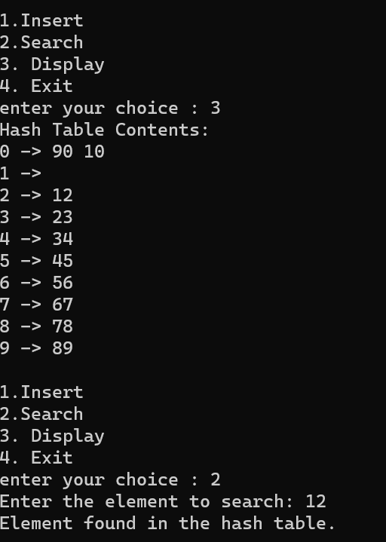

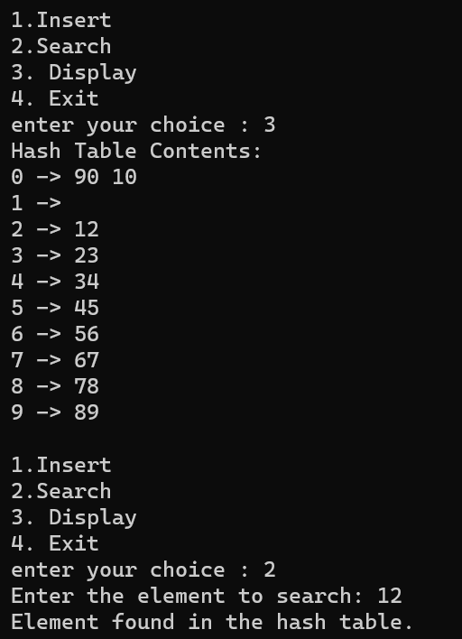

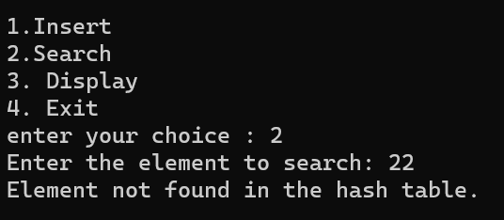

2. Create another hash table ADT with following functions for open addressing methods, namely, Quadratic probing and Double Hashing.
- void insertElementL (HashTableADT *H, int x)– To insert the input key into the hash table
- void displayHT(HashTableADT *H) – Display the elements in the hash table

Note: For Double hashing, the second hash function is 7-(x%7)

Demonstrate the ADT with the following testcase
(i) Contents of Hash Table
(Quadratic Probing)
0 →
1 →67
2 →53
3 →23
4 →54
5 →45
6 →66
7 →87
8 →48
9 →69

(ii) Contents of Hash Table
(Double Hashing)
0 →67
1 →
2 →53
3 →23
4 →54
5 →45
6 →66
7 →87
8 →48
9 →69

